DEALS TO PLAYA DEL CARMEN

This fun beach town on Mexico’s Yucatan Peninsula, which is less touristy and smaller than Cancun, is a perfect spot for those seeking to chill out in Mexico without necessarily going the resort route. Book a trip to Playa del Carmen via Cancun International Airport on Virgin America. Live it up at 35,000 feet with WiFi, on-demand entertainment, and more on every flight.

(MARKET IMAGE HERE)

Find Deals From These Cities

INSERT FARE GRID FROM / TO Version (if available!)



Top Things To Do in Playa del Carmen

We’ve rounded up a few of the best Playa del Carmen activities for you to partake in while you’re there.

* Check out the night scene. Playa del Carmen’s Quinta Avenida pedestrian thoroughfare runs parallel to the beach and has a ton of different types of restaurants and nightspots. Whether you’re more of a laid-back bar type or prefer dance clubs, you’ll find something you enjoy here.
* Swim with sea turtles. Take a trip to Akumal and go snorkeling. In the transparent blue water you’ll be able to spot huge sea turtles all around you.
* Try a new water sport. This coastal town has plenty of different water sports for you to experience. Rent a jet ski, go sailing, learn to kite-surf…pick something you’ve never done before and have a blast!

Travel Tips and Resources

[Must-Dos in Playa del Carmen](http://www.travelyucatan.com/playa_del_carmen_attractions.php)

[Playa del Carmen Hotels](http://www.tripadvisor.com/Hotels-g150812-Playa_del_Carmen_Yucatan_Peninsula-Hotels.html)

[Playa del Carmen Restaurants](http://www.tripadvisor.com/Restaurants-g150812-Playa_del_Carmen_Yucatan_Peninsula.html)

[Playa del Carmen Shopping Guide](http://www.playadelcarmen.com/information/shopping)

[Playa del Carmen Nightlife and Entertainment](http://www.bestday.com/Playa_del_Carmen/Nightlife)

[Playa del Carmen Travel Tips](http://www.playadelcarmen.com/information/faq)

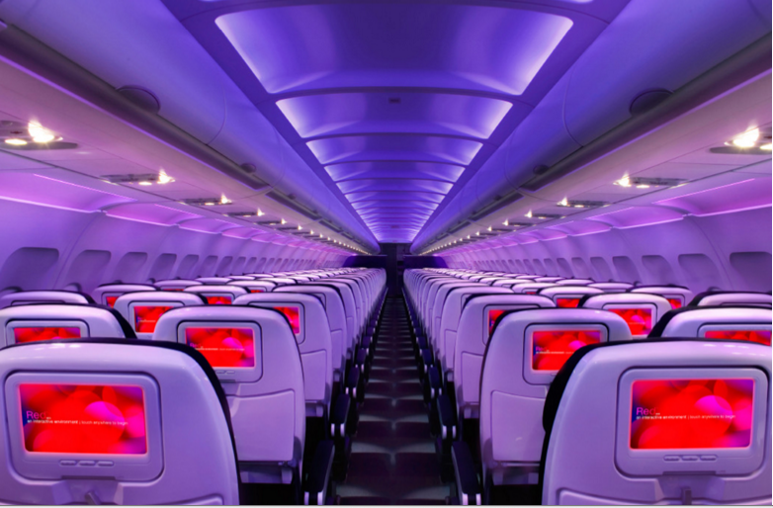

Main Cabin Main Cabin Select First Class

(add links to Cabin Class Pages)

Ready. Set. Fly.

Book your Mood-lit Ride to Playa del Carmen.

Looking for Playa del Carmen flights? Fly into Cancun International Airport with Virgin America and rent a car (or arrange for public transportation) to Playa del Carmen, which is under an hour away. Experience what it’s like to fly in comfort and style when you fly with us. With amenities such as on-demand food ordering and entertainment, you’ll have everything you need to enjoy your time in the air.

Take a Virtual Tour

Add Terms & Conditions